Title or Task: | Creating Motion Tweens in Flash
Description: | Various motion effects

Files Required
Suitable for Classes: | AIT • Multimedia • Cert II IT • Cert II Bus
Area: | Technology & Enterprise
Teacher: | Mr Peter Faulks
Timeline | 2 lessons

Date Due:
Task Brief: | Create Flash as directed
Outcomes: | Ability to create animations in Flash




Items highlighted in yellow are tasks for you to complete
Items in Blue italics are help tips

These pages are designed to show you how to use software packages; various software updates may have taken place so some pages will not apply to versions other than those listed here. In some cases data files may be required.

Flash Animation - Motion tweening
One of the basic animation techniques is moving an object from one location to another. This is accomplished in Flash by applying a Motion Tween between the start and the end frames.
Step 1
Open a new file. Select Flash File (ActionScript 3.0)
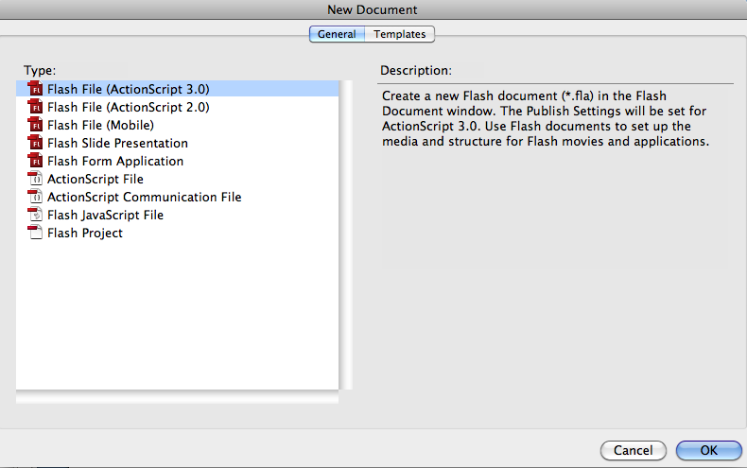
You'll notice that this movie has only one layer called Layer 1.
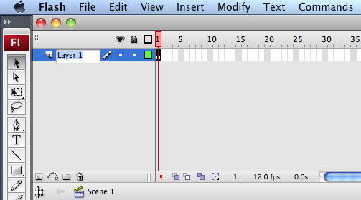
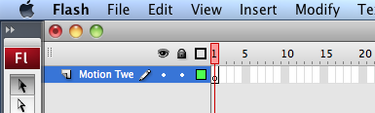

It is always a good practice to put descriptive names of your choosing for the layers in a Flash file. To rename Layer 1, double click on its name and then type the new name, something like "Motion Tween".
Step 2
Our stage is set and it is now time to create an object.
Highlight the first frame in the Time line and using the Oval Tool and draw a circle somewhere on the stage.

Step 3
To animated this circle so that it moves from one place to another, we have to convert it into a Symbol.
Click on the Arrow tool and select the circle you have just drawn. Flash places a sort of 'net' over selected objects. The image below shows what a selected and an unselected circle looks like.
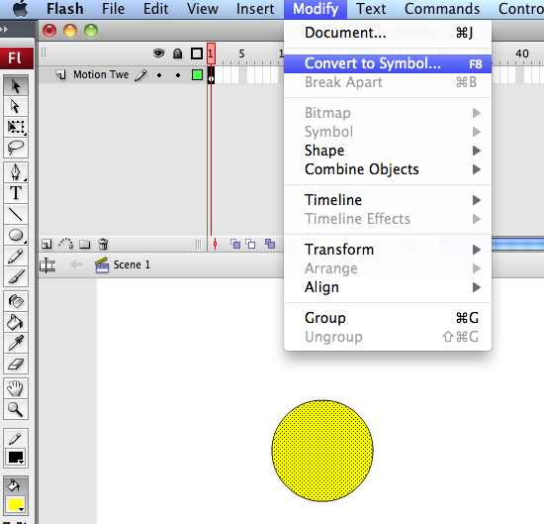
Now click on Insert or Modify (CS3) - Convert to Symbol. The Symbol Properties window pops up. In the name text field type "Ball" which is the name for our symbol and also make sure that the Behavior is set to Graphic (that is the default value). Click OK to convert the circle into a symbol.
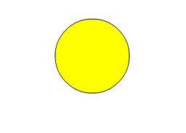
Step 4
If the Symbol Library is not open, click Window - Library to display the library in which you will find your newly created symbol, "Ball". Click on its name to view the a thumbnail of the object. 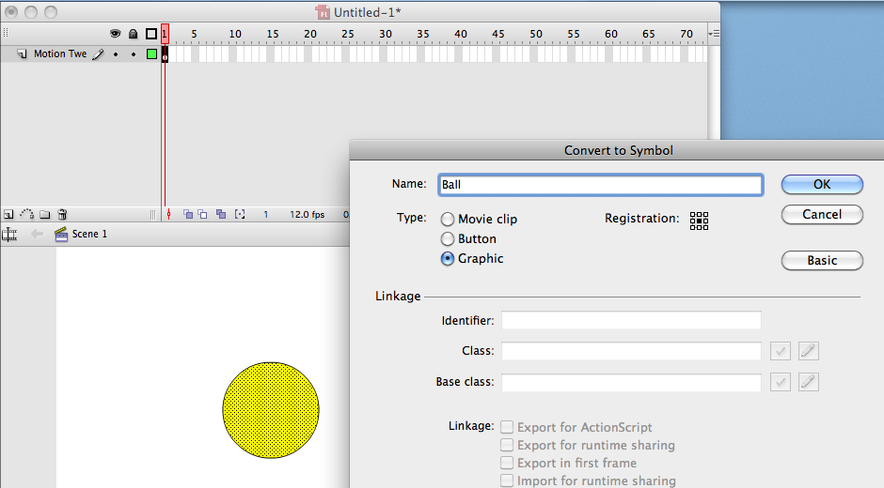

Step 5
Place the circle (which is now a symbol) somewhere near the top-left corner of the stage.

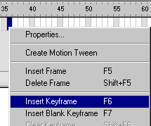
Now right-click frame number 36 in the time line and select Insert Keyframe
This adds a key frame at frame 36.

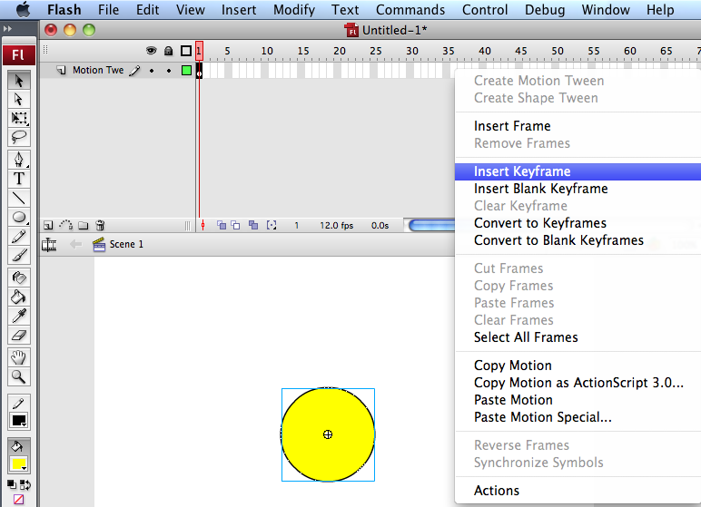

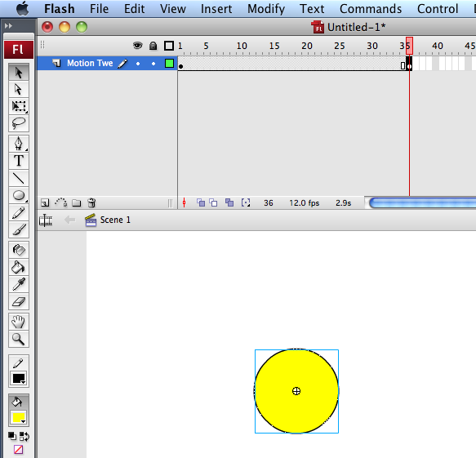

With this frame selected, move the circle symbol and place it near the top-right corner of the stage. Thus, the circle is placed at its staring point (top-left) in frame 1 and at its ending point (top-right) in frame 36. We are all set to apply the animation.
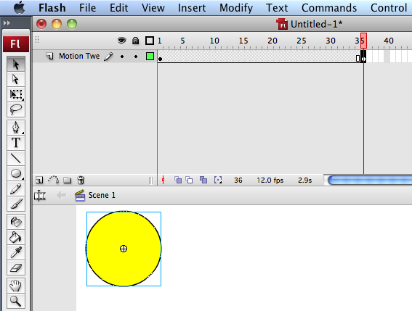

Step 6
The last step is creating a Motion Tween between frame 1 and frame 36.
Right-click at any frame between 1 and 36, and from the drop down menu select Create Motion Tween
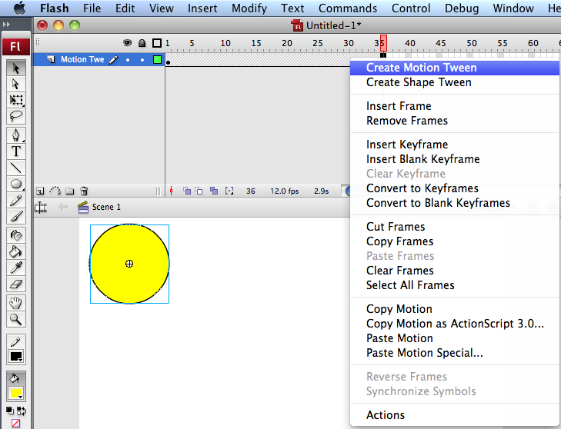
With the motion tween applied between frames 1 and 36, the layer should look something like: Notice the arrow
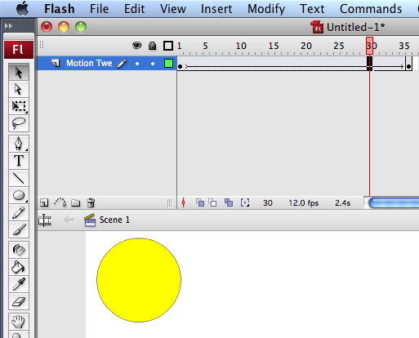

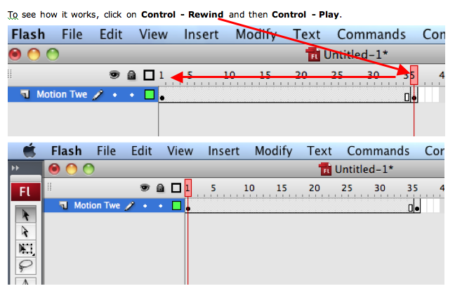
Click on the button below to see is what I made:

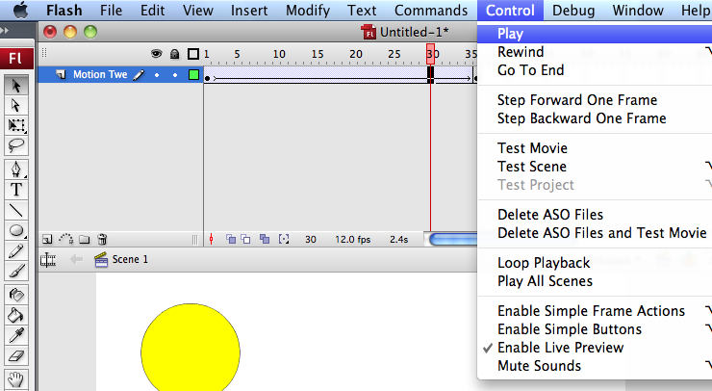

Congratulations

If your circle moved across the screen?
Save as Move.fla

Advanced version Creating Motion Tween in Flash

Draw a vector using any of the drawing tools in Flash, say a small circle and convert it into a symbol (F8) by selecting the Graphic option and name the symbol say 'ball'.

Click the 20th frame in the Timeline and insert a frame (F5).
Title your layer as Ball
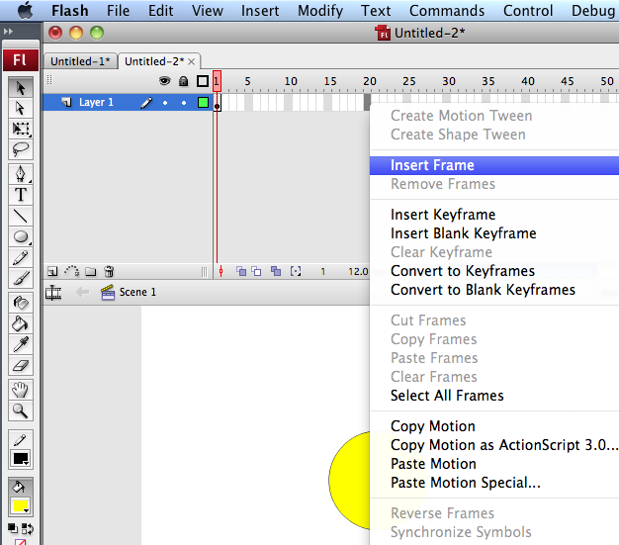
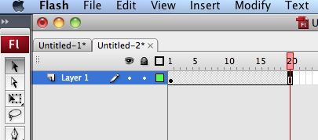

Now right-click the 20th frame in the Timeline and select Create Motion Tween (or Motion option from the Tween panel of the Properties inspector) and insert a Key Frame (F6).
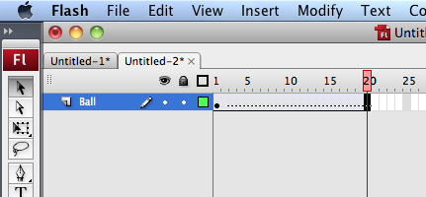

Select the 10th frame and insert a Key frame (F6) and move the ball to a different position say, above the current position to create a motion sequence (automatically tweened by Flash).
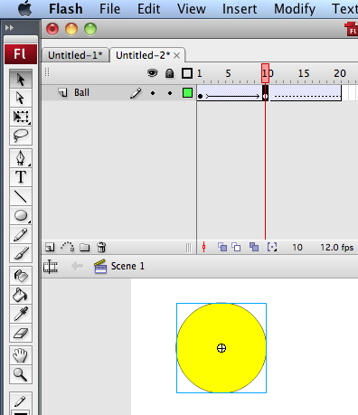

Save your work and test the Movie (Ctrl + Enter). That's it you have created simple animation using Motion Tween.
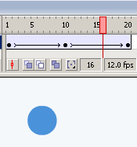
Fig: Timeline of Motion Tween

Note: Select the circle (ball) and use the Color Panel of the Properties inspector to reduce the Alpha value from 100 to 32 for the last frame.

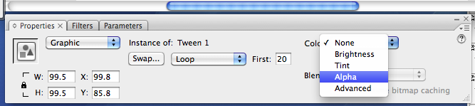

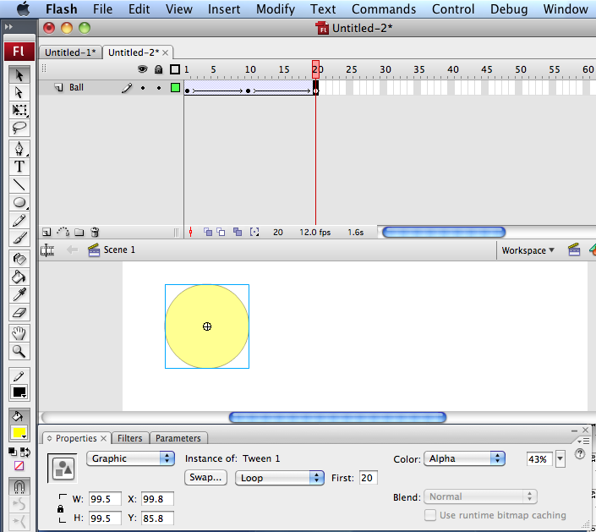

1st frame change the tine so that your animation moves and changes colour
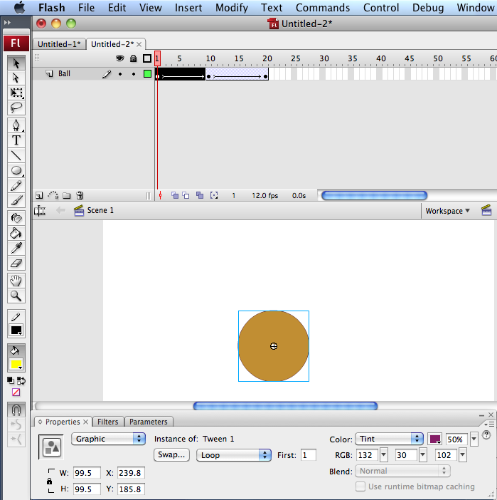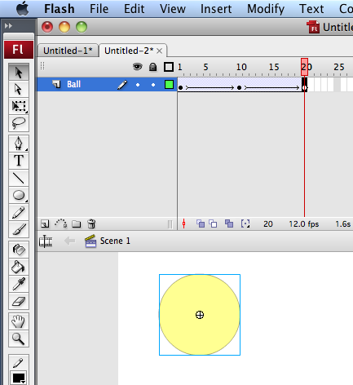

Did your animation work? Save as ShapeColour.fla

Creating Shape Tween in Flash

You can create Shape Tweened animations using Shape option from the Tween panel of the Properties inspector. Draw a vector using any of the drawing tools in Flash, say a small circle and remove its border. (Click on pointer tool on the ball edge, and then cut).
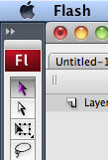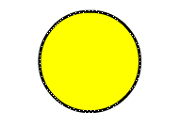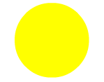

Click the 10th frame in the Timeline and insert a Key Frame (F6). Now draw another shape say a polystar using the polystar tool without a border.
Note: To remove the borders you will need to shift click each side with the pointer tool and then cut to remove the border.

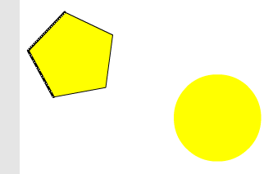
Now right-click on any frame in between these two Key Frames and select Shape option from the Tween panel of the Properties inspector.
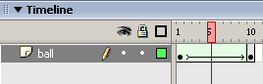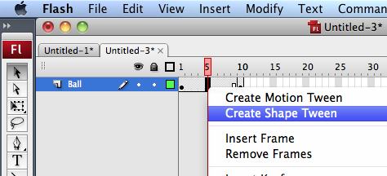

Save your work and test the Movie (Ctrl + Enter). That's it you have learnt how to create Shape Tween in Flash.
Save as Vector Move.fla

Fig: Timeline of Shape Tween

Note: Only vectors can be Shape Tweened (Not for Symbols).

Note: both the Tweens have different colors along the Timeline as shown above. Make sure that the line is smooth without being broken to ensure correct Tweening.
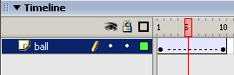
Fig: Timeline of Broken Tween

Frame-by-Frame Animation

Create a vector/plain text using any of the drawing tools in Flash, say a text with 'Animation' typed as shown in the example

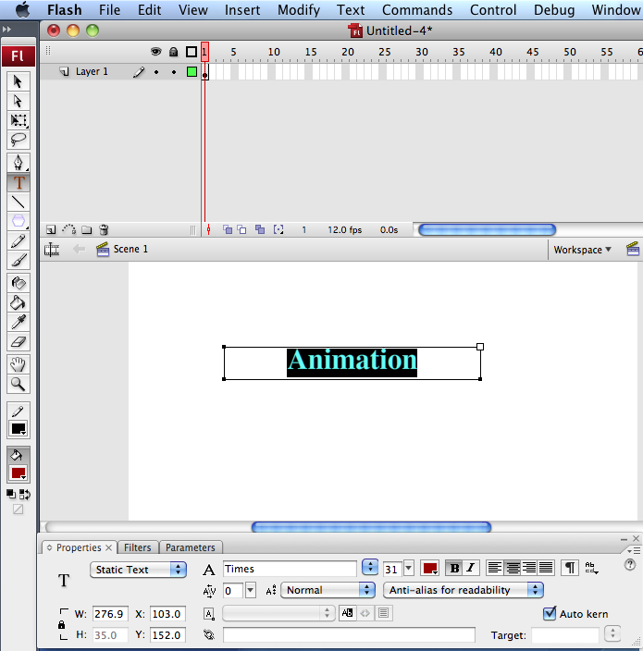
and break it using Break Apart (Ctrl + B) to separate the alphabets as shown below:
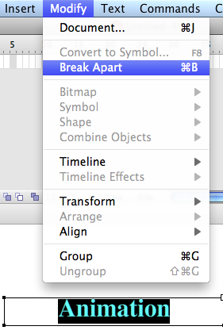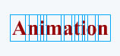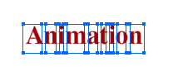
Fig: Showing Text after Break Apart

In Frame-by-Frame animation we create the object for each frame so as to produce an animation sequence.

Insert Keyframe (F6) and move the alphabets so as to produce an animation sequence. I used evert 5th frame to insert keyframe and move
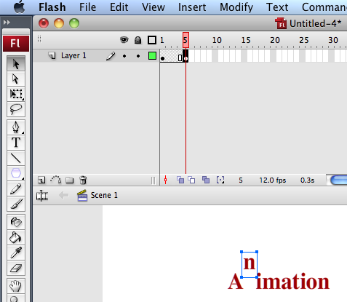
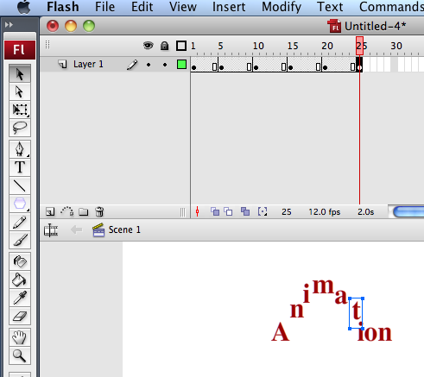
Repeat the above step as far as desired to create Frame-by-Frame animation as shown in the example.

Save your work and test the Movie (Ctrl + Enter). That's it you have created an animation using Frame-by-Frame animation.
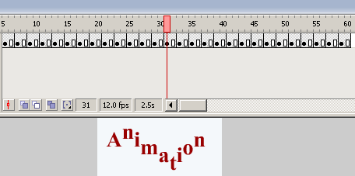
Fig: Timeline of Frame-by-Frame Animation

Create the Flash again but change the letters to represent your name and save as myname animation.fla

Creating a Guided Motion Tween in Flash

Create a vector/plain text using any of the drawing tools in Flash, say a text with 'Your first name' typed and break it using Break Apart (Ctrl + B) as done in the previous example

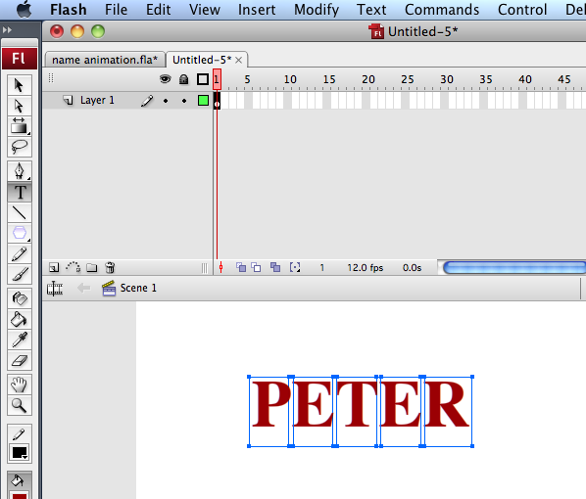

Delete your name then create a layer for each letter Put each letter of your name in different layers and name the layers as shown in the picture below.

In Layer 2 Type the first letter of your name

Layer 3 Next letter etc.
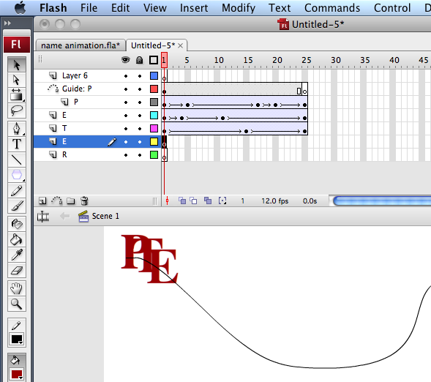

Insert a guide layer by right-clicking the topmost layer and select 'Add Guide Layer' (Insert-->Timeline-->Motion Guide), draw any path using the pencil tool in the guide layer as shown in the example.

Now create Motion tween by selecting the object in the 1st frame and snapping its registration point to one end of the path.

Snap the object in the last frame to the other end of the path in the guide layer.

Repeat the same for all the objects (alphabets) by snapping their registration points to the path in the guide layer.

Save your work and test the Movie (Ctrl + Enter). That's it you have learnt how to create motion along a guided path.
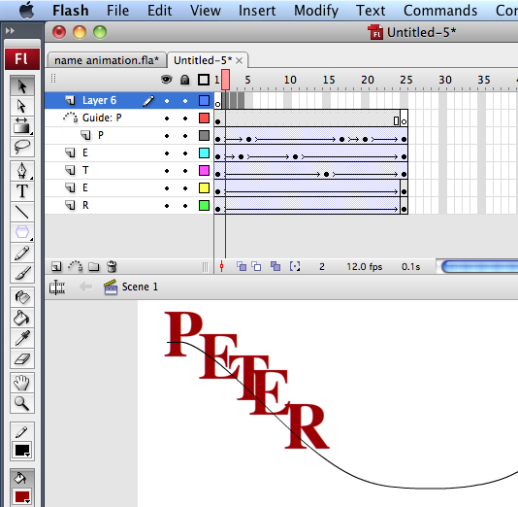
Fig: Timeline of Guided Motion Tween
http://www.smartwebby.com/Flash/flash_animations.asp



